# Empathy Map - Jewel Management System

**Project Name**: Jewel Management System  
**Date**: 28 June 2025  
**Team ID**: LTVIP2025TMID30526  
**Target User**: Jewellery Store Admin / Goldsmith / Worker

## Empathy Map

|  |  |
| --- | --- |
| Says | “I want to easily manage gold and silver inventory.” “I need to track customer orders and billing details.” “I hate switching between multiple systems to fetch price or stock info.” |
| Thinks | “Is the purity-based gold price being calculated correctly?” “Are the roles assigned to goldsmith and worker properly restricted?” “Will my dashboard reflect accurate sales and order data?” |
| Does | Creates jewel customer, item, order, and billing records Assigns roles using profiles and permission sets Views dashboards and runs reports for inventory and sales Uses formula fields, flows, and triggers to automate tasks. |
| Feels | Stressed if gold/silver prices are not updated Anxious about incorrect billing or KDM/making charge calculations Frustrated with manual validations and repeated entry errors. |

**💎 Jewel Management System**

📄 **Project Name**: Jewel Inventory System  
📅 **Date**: 28 June 2025  
🆔 **Team ID**: LTVIP2025TMID30526

🔹 Problem Statement 1:  
I am a jewellery admin or store manager.  
I’m trying to manage customer records, gold and silver item details, billing, and pricing in one place.  
But the current system involves manual entry, lacks automation, and is prone to pricing errors.  
Because there is no integrated system that validates inputs or auto-calculates pricing logic based on purity, item type, and weight.  
Which makes me feel stressed and frustrated about delays, incorrect billing, and customer dissatisfaction.

🔹 Problem Statement 2:  
I am a goldsmith or worker.  
I’m trying to update item information, check assigned orders, and view pricing details.  
But I don’t have clear access controls or automated support for my tasks.  
Because permissions and user interface customization are not role-specific or dynamic.  
Which makes me feel limited and unsure if I’m working with the right data and tools.

| **Field** | **Response** |
| --- | --- |
| **I am** | A Jewellery Admin |
| **I’m trying to** | Manage orders, customers, items, and billing efficiently with automated price calculations |
| **But** | The existing process is slow, error-prone, and disconnected |
| **Because** | There's no role-specific workflow, formula-based automation, or dynamic validation |
| **Which makes me feel** | Frustrated, uncertain about data correctness, and worried about customer trust |

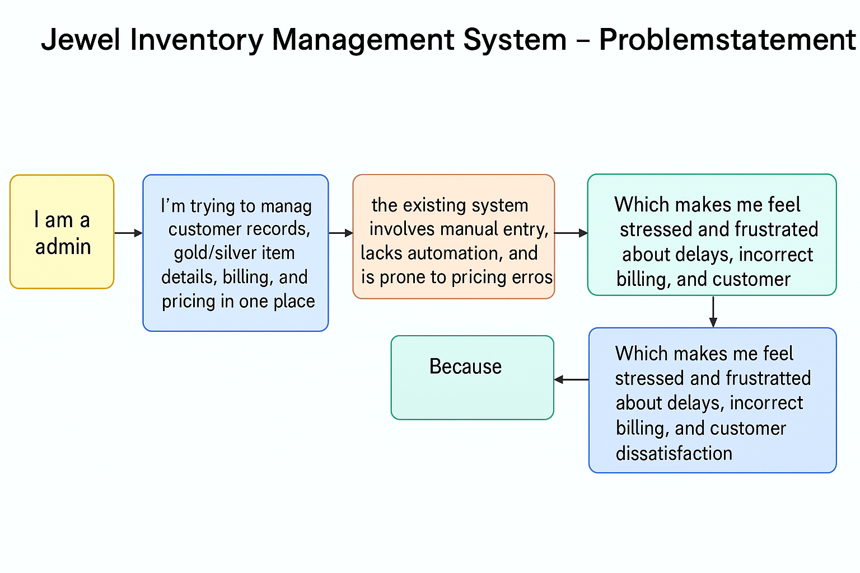

## Brainstorming & Idea Prioritization

📄 **Project Name**: Jewel Inventory System  
📅 **Date**: 28 June 2025  
🆔 **Team ID**: LTVIP2025TMID30526

**Step 1: Problem Statement**

Lack of integration between item inventory, customer order processing, and automated pricing with role-based access.

**Step 2: Idea Listing**

* Create custom Salesforce objects: Jewel Customer, Item, Customer Order, Billing, and Price
* Use **Lookup** and **Master-Detail** relationships to connect data across objects
* Use **Formula Fields** to calculate:
  + Total Weight, Amount, Purity-based Pricing, KDM, Making Charges
* Use **Validation Rules** to enforce field-level accuracy (e.g., postal code, expected return)
* Create **Profiles** and **Roles** (Goldsmith, Worker) with specific access
* Assign users with specific **Permission Sets** for Gold/Silver record types
* Design **Lightning App** with tabs and a console-based UI for navigation
* Use **Flows** to send dynamic email alerts to customers post-billing
* Create **Reports** (e.g., Item with Billing, Billings with Order and Customer)
* Create **Dashboards** to track:
  + Item types sold
  + Revenue generated
  + User assignments
* Use **Apex Triggers** and **Handler Classes** to automate paid amount updates

## Step 3: Prioritize Ideas

|  |  |
| --- | --- |
| Ideas | Priority |
| Object Creation and Relationships | High |
| Formula Fields for Price Logic | High |
| Role-Based Page Layout & Record Types | High |
| Flows for Email Notification | High |
| Trigger + Handler Class for Paid Amount | High |
| Validation Rules | Medium |
| Dashboard Visuals | Medium |
| Employee Reports (Goldsmith/Worker-wise) | Medium |